Blizzard Builder

User Manual

Hayden Streib

Final Project

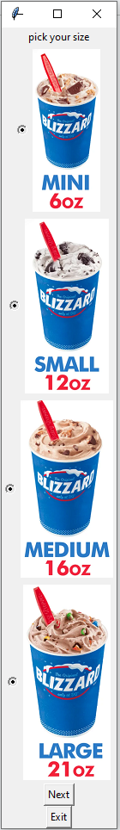

This program is a blizzard builder for Dairy Queen and will allow the user to pick their size, soft serve flavor, and their toppings of choice. After creating, the program will print a final summary of your order, including the price.

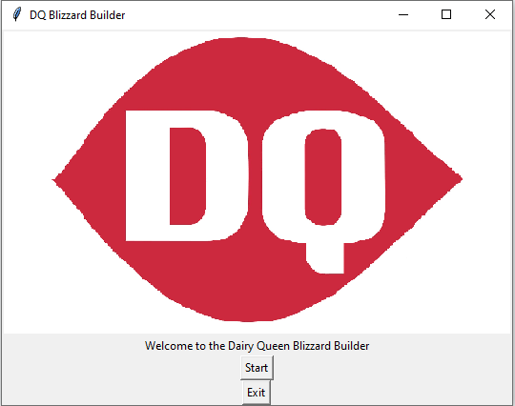

Start menu

The start menu shows the start button and the exit button along with the dairy queen logo. The exit button will show on every page.

Size Selection

This window will show 4 buttons with included pictures for each size. Each picture labels the size and the ounces. This window and the next now include the *Next* button. Each *Next* button, when clicked, will check if the user has made a selection or not and will deliver a warning message if needed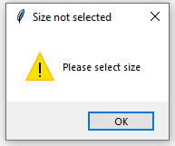

Soft Serve Selection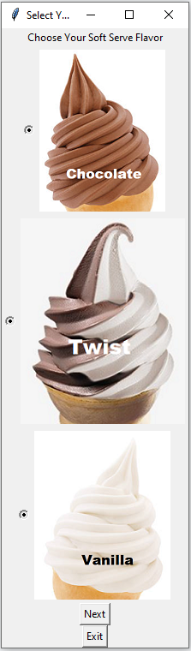

This window shows 3 buttons with included pictures for each soft serve flavor; vanilla, chocolate, and twist. After selecting, use the next button to continue.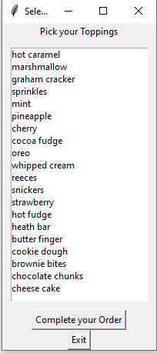

Topping selection

This window will show a listbox allowing the user to select as many toppings as they want. This version includes 20 different toppings for the user and will show an order completion button at the bottom. Clicking this button without a topping selected will also show a warning message.

Order Summary

This window will show the user’s completed blizzard order separated into four lines; price, size, flavor, and toppings. The included price will depend on what size they chose. 